UNDERSTANDING AND MAINTANCE OF NETWORK

Assignment day-3
TASK1: Log in to your home Wi-Fi router's admin panel using its default IP address (usually 192.168.0.1 or 192.168.1.1) and take a screenshot of the login page.<br><br><em><strong>Hint:</strong> If you don't know your router's IP, open Command Prompt and run 'ipconfig' — look for 'Default Gateway'.</em>
STEPS:-
1.Connect your laptop or mobile to your Wi-Fi.
2.Press Windows + R, type cmd, and press Enter.
3.Type:ipconfig
4.Find the Default Gateway (for example, 192.168.1.1).
5.Open a web browser.
6.Enter the Default Gateway IP (such as http://192.168.1.1) in the address bar.
7.The router login page will appear.
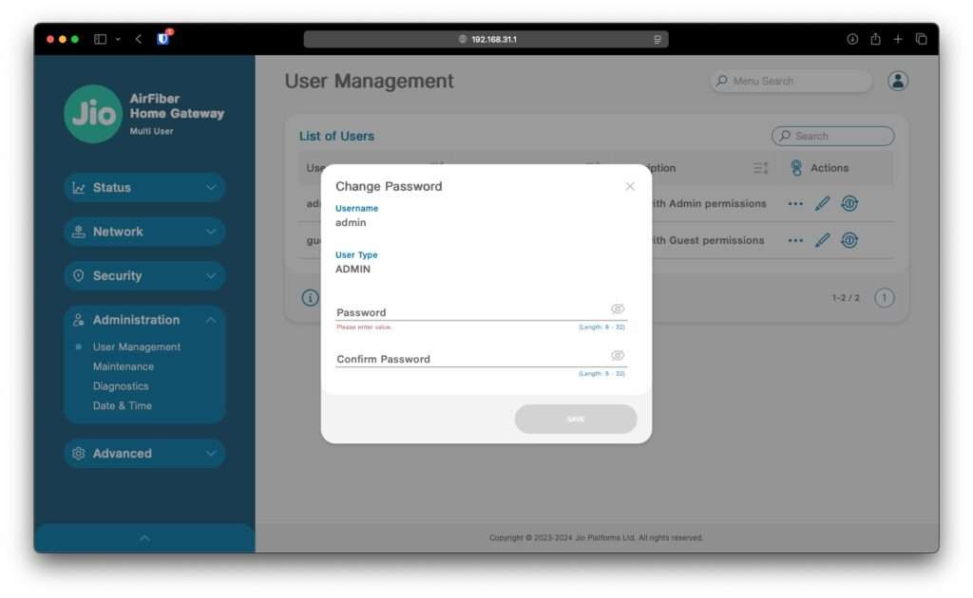
TASK2: Find and note down the current IP address, subnet mask, and default gateway assigned to your laptop or mobile device when connected to your Wi-Fi network.
STEPS:-
1.Open Command Prompt.
2.Type: ipconfig
3.note the following
Setting | Example Value
IP Address | 192.168.1.100
Subnet Mask | 255.255.255.0
Default Gateway | 192.168.1.1

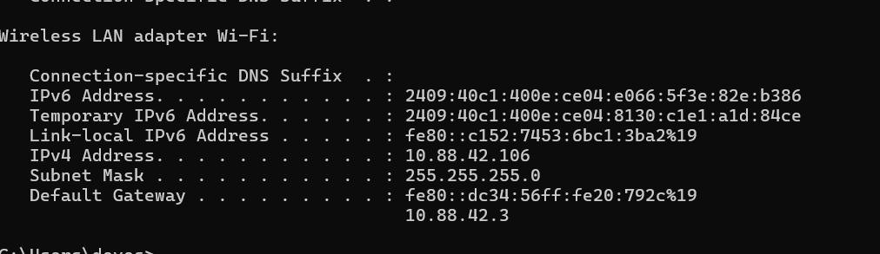

TASK3: Change your device's IP address from 'Obtain IP automatically' (DHCP) to a static IP in the same range as your router (for example, set it to 192.168.1.50 if your router is 192.168.1.1), and test if you still have internet access.<br><br><em><strong>Constraint:</strong> Remember to revert to automatic/DHCP after testing to avoid network issues.</em>
STEPS:-
- Open Control Panel.
- Go to Network and Sharing Center.
- Click Change adapter settings.
- Right-click Wi-Fi → Properties.
- Select Internet Protocol Version 4 (TCP/IPv4).
- Click Properties.
- Select Use the following IP address.
- Enter:
Setting | Example
IP Address | 192.168.1.50
Subnet Mask | 255.255.255.0
Default Gateway | 192.168.1.1
Preferred DNS | 8.8.8.8
Alternate DNS | 8.8.4.4
- Click OK.
- Open a browser and check if the Internet works.
- After testing, return to TCP/IPv4 Properties.
- Select Obtain an IP address automatically and Obtain DNS server address automatically.
- Click OK.

TASK4: In your router's admin panel, locate the section where you can view or change the DHCP range. Write down the current range, and explain in 2-3 lines what would happen if two devices are assigned the same IP address in this range
STEPS:-
- Log in to the router admin panel.
- Open the LAN or DHCP Server section.
- Note the DHCP IP address range.
- SAMPLE DHCP RANGE
Setting | Example
Start IP | 192.168.1.100
End IP | 192.168.1.200

